**Lab report 01**



**CSE 402L**

**Digital Signal Processing Fall 2024**

**Submitted by: Naveed Ahmad**

**Registration No.: 22PWCSE2165**

**Class Section: B**

**Semester :5th**

*“On my honor , as student of University of Engineering and Technology, I have neither given nor received unauthorized assistance on this academic work”*

Student Signature: ____________

Submitted to:

**Dr. Yasir Saleem Afridi** Oct 1, 2024

Department of Computer Systems Engineering

University of Engineering and Technology Peshawar

# COMMANDS

**SECTION 1: Save and Load Variable:**

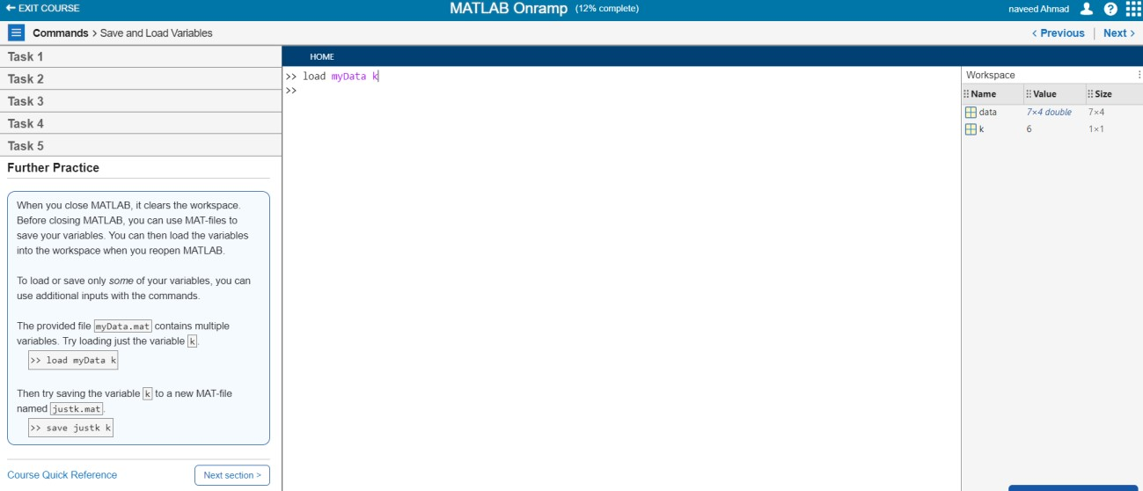

In this section, I learned how to use MATLAB's save and load functions to efficiently manage variables, ensuring data preservation and easy retrieval for future analysis.

**SECTION 2:use Built-in Function and Constant:**

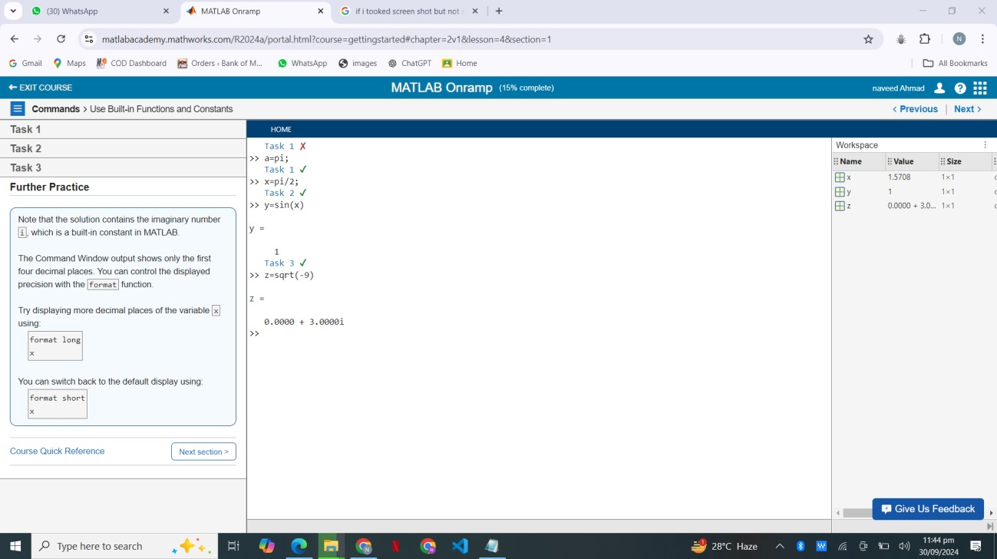

In this section, I learned about MATLAB's built-in functions, which provide powerful tools for various tasks, improving efficiency and functionality in my programming. Understanding these functions is essential for effective coding and problem-solving.

**SECTION 3: The MATLAB Editor:**

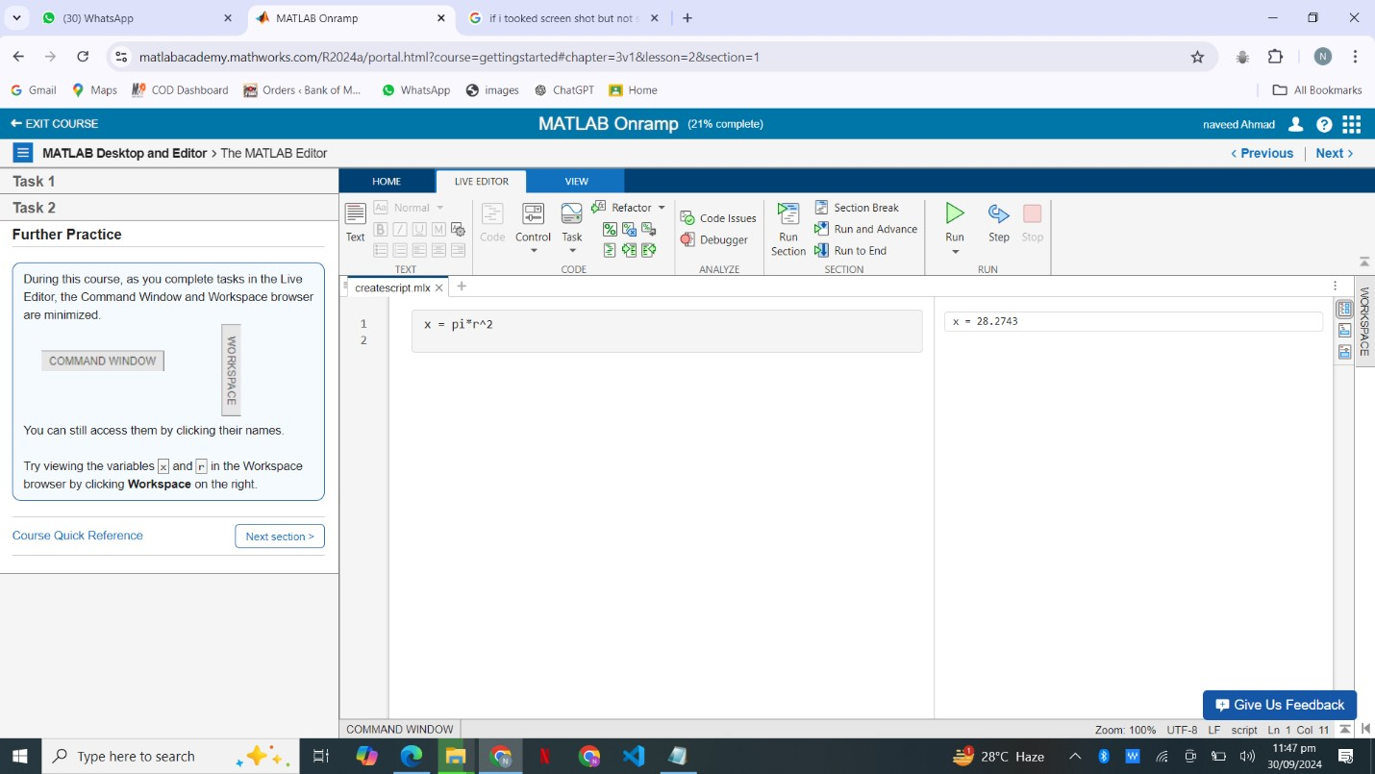

In this section, I delved into MATLAB's built-in functions, which provide key tools for various tasks, boosting efficiency and enhancing my programming skills. Familiarity with these functions is vital for effective coding and problem-solving.

**SECTION 4: Running The Script:**

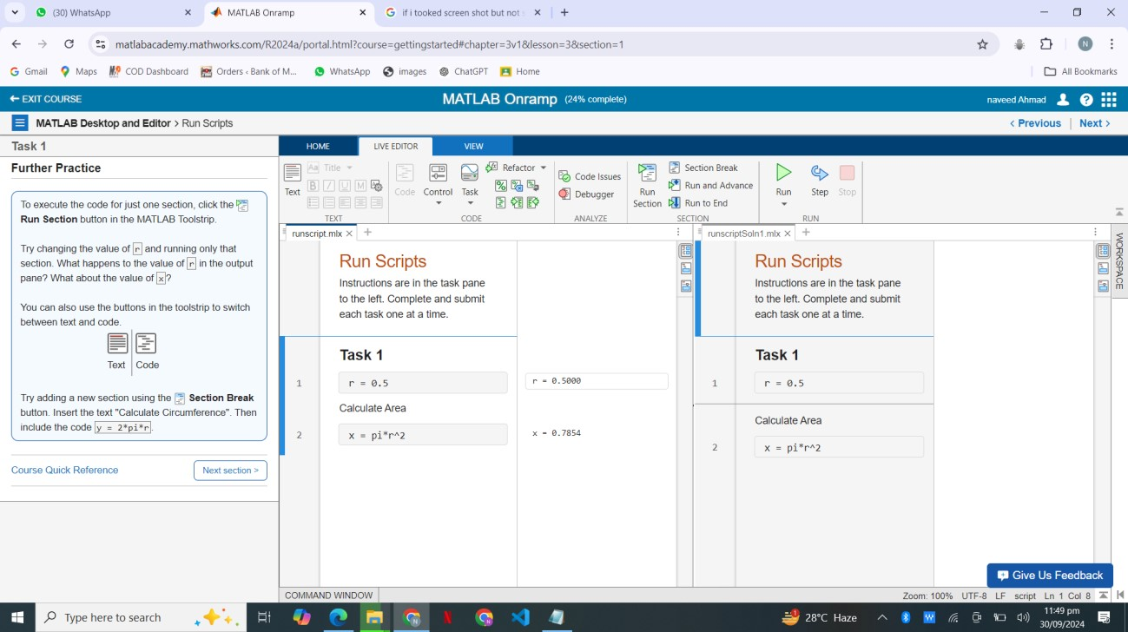

In this section, I learned how to run scripts in MATLAB, which allows for efficient execution of code and testing of functions. Mastering script execution is essential for effective programming and debugging.

**SECTION 5: Debug MATLAB Code.**

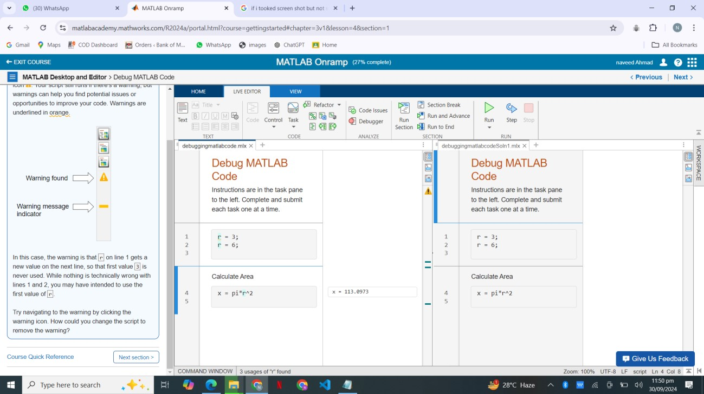

In this section of course l learned how to debug and improve the code and make it errorless.

**SECTION 6: Manually Entering Array:**

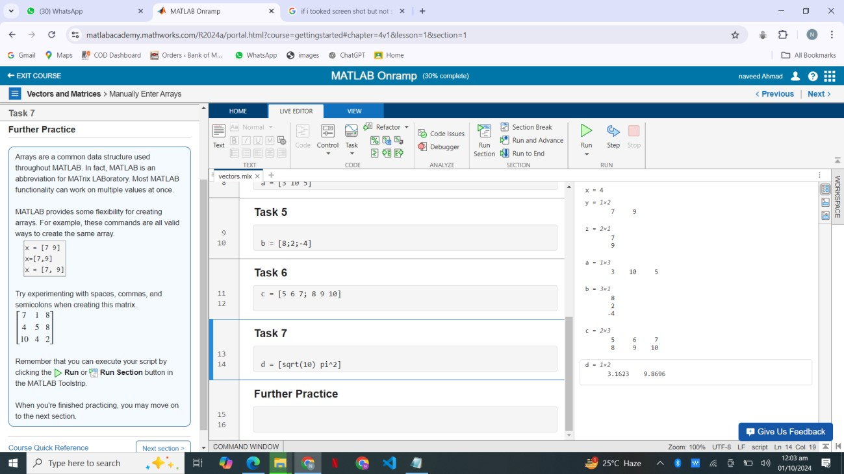

After the completion of this section, I’m able to use array and enters it indexes manually.

**SECTION 7: Creating Evenly Space Vector:**

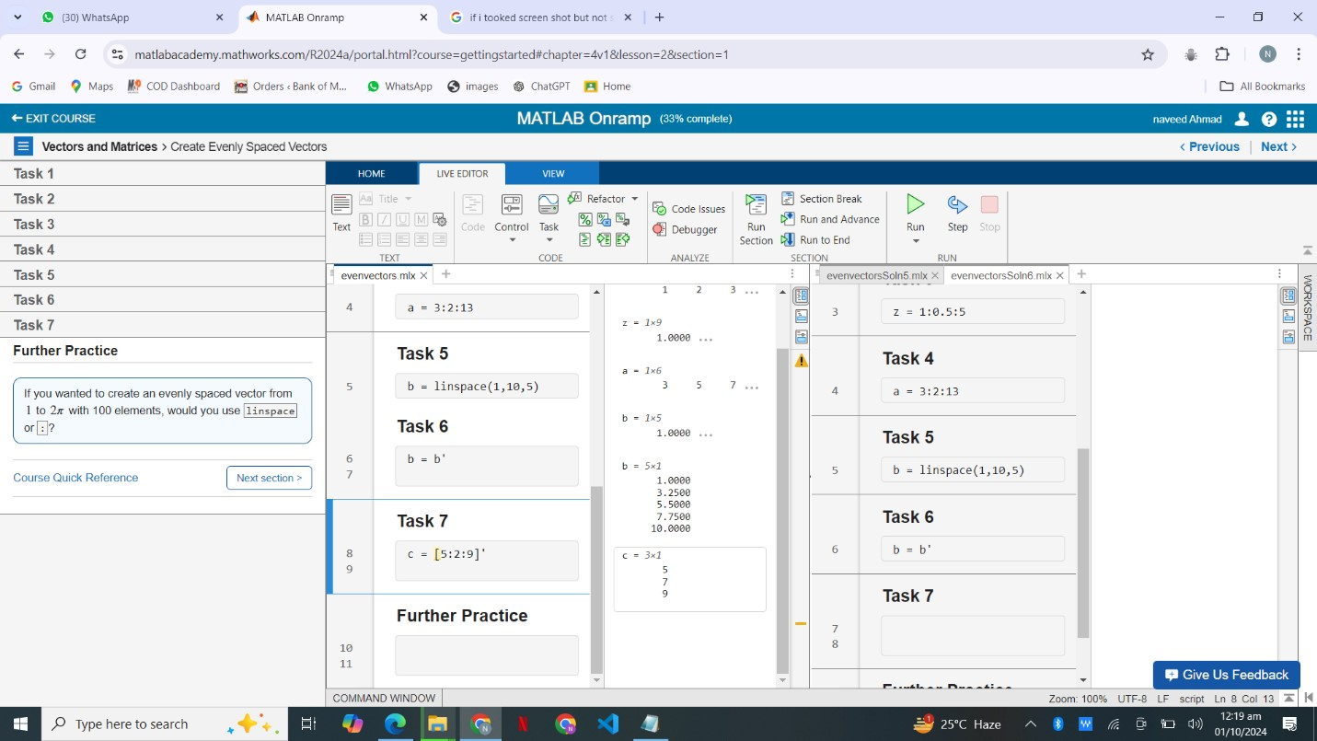

In this section, I learned how to create evenly spaced vectors in MATLAB using functions like linspace and colon (:). This technique is fundamental for generating data sets and facilitates various mathematical operations and analyses.

**SECTION 8: Creating Array with Function:**

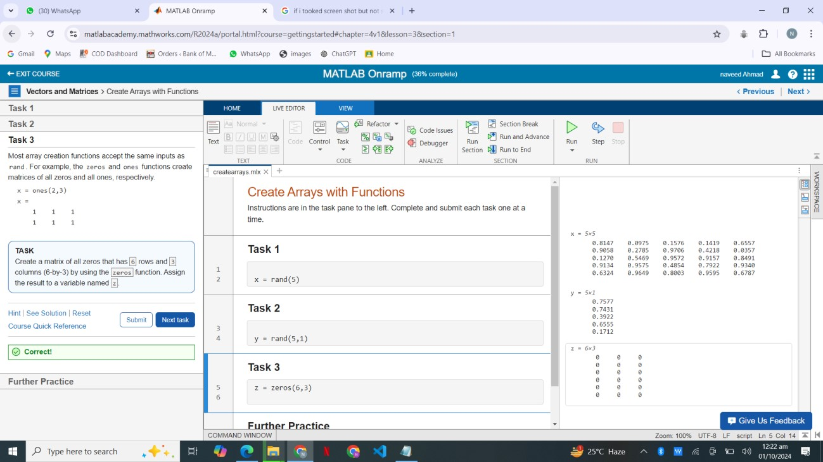

In this section, I explored how to create arrays using built-in functions, such as zeros, ones, and rand. This skill is essential for initializing data structures and performing numerical computations effectively.

**TASKS 1,2,3:**

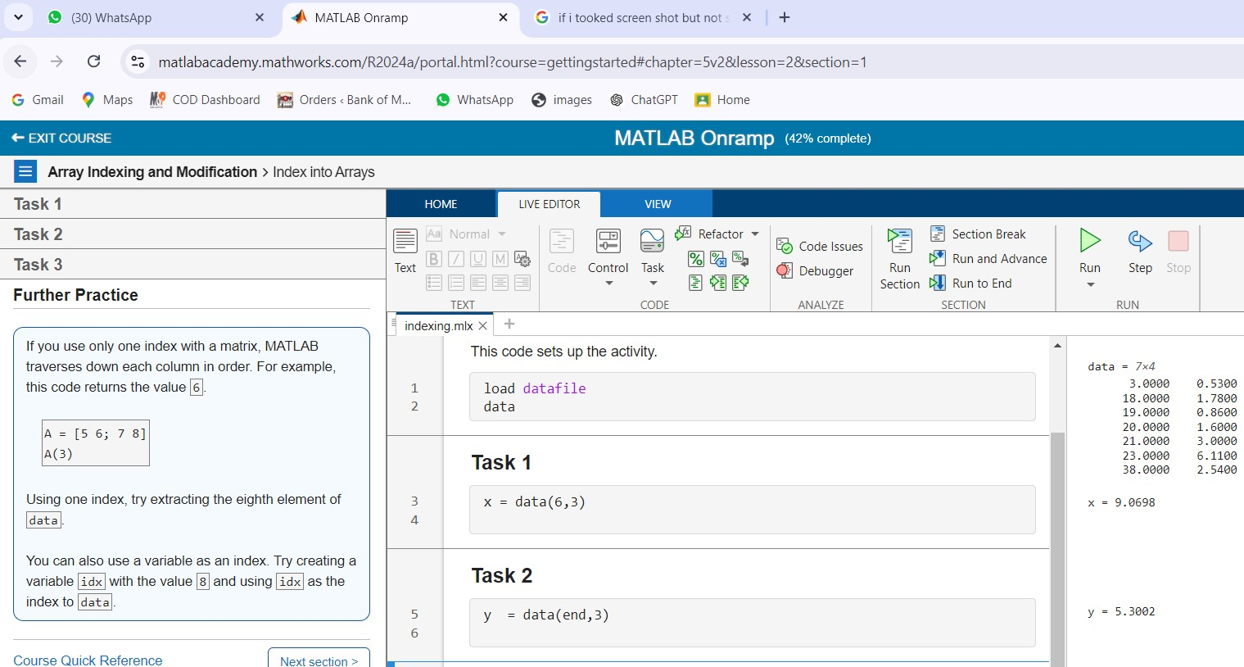

**SECTION 9: Extracting Multiple Functions:**

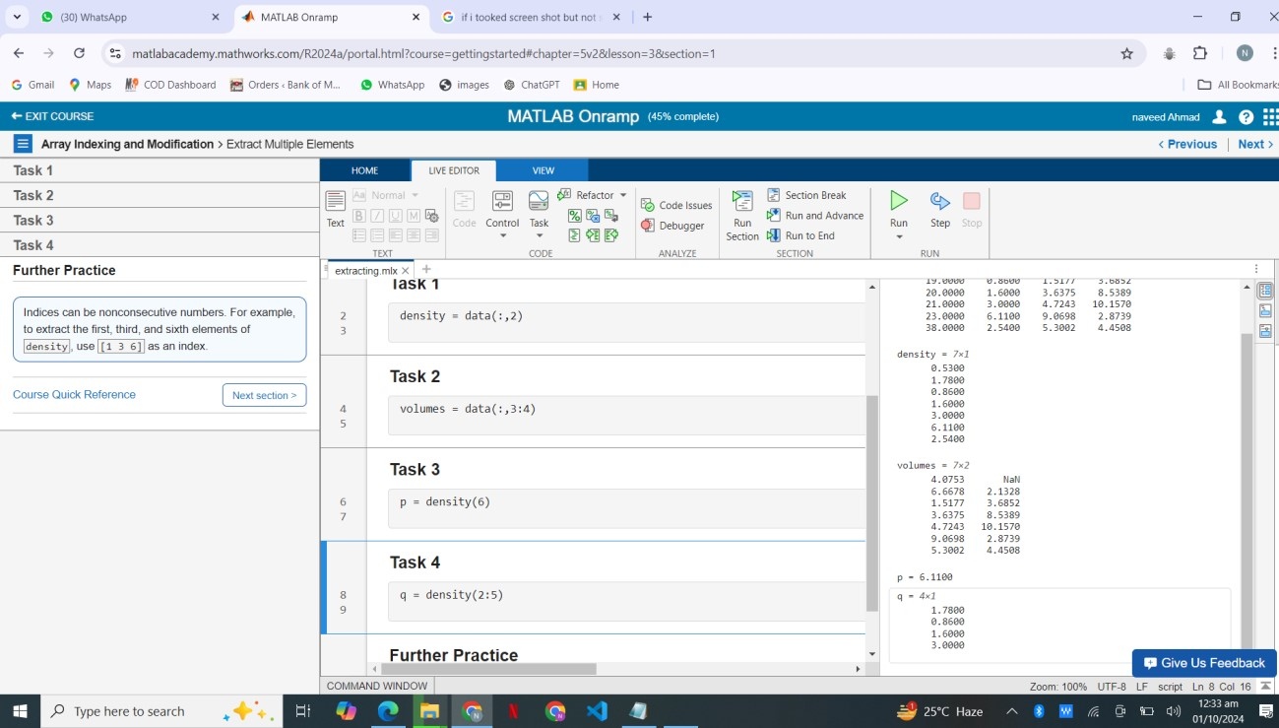

In this section, I learned how to extract multiple functions in MATLAB, allowing for efficient data manipulation and analysis. This skill enhances my ability to streamline processes and handle complex data sets effectively.

**TASKS 1,2,3: Changing Values In Array:**

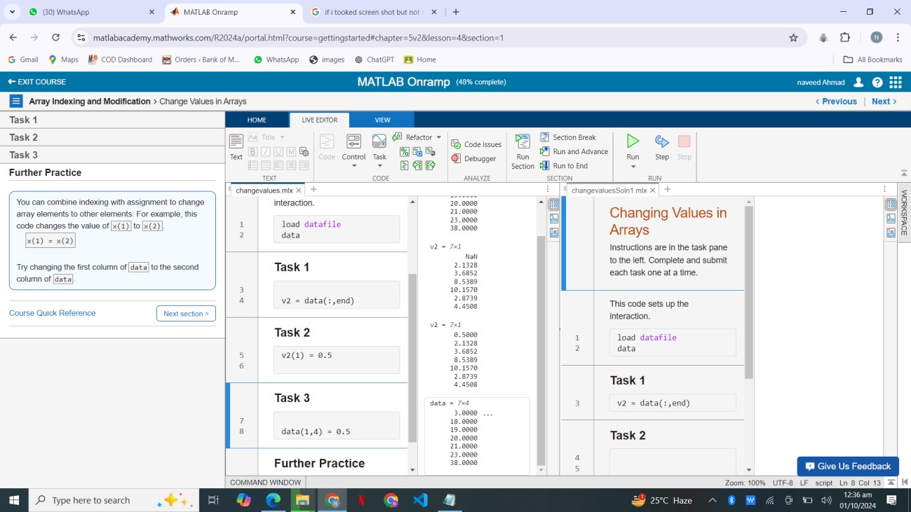

In this section, I explored techniques for changing values in an array, which is crucial for data manipulation and analysis. Mastering these methods allows for greater flexibility in modifying datasets and improving overall functionality.

Round function: Performing Array Operation on Vector.

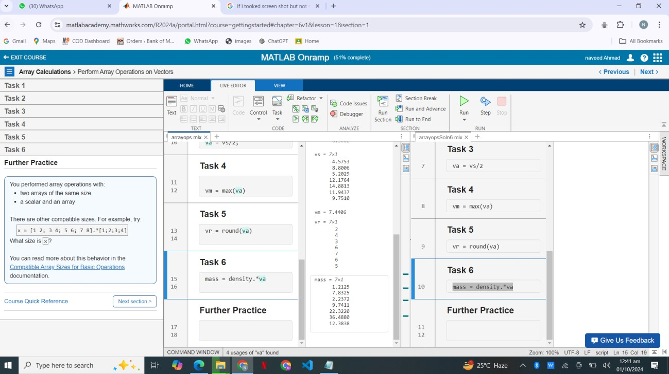

In this section, I learned how to perform array operations on vectors, enabling efficient mathematical computations and data analysis. This skill is essential for manipulating and processing data effectively in my projects.

# Data import: Importing data as a table:

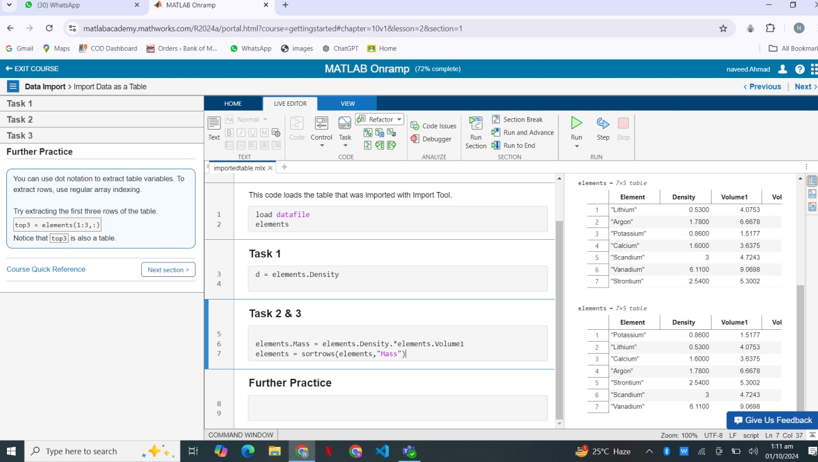

In this section, I learned how to import data as a table in MATLAB, which simplifies data organization and analysis. This approach enhances my ability to handle structured datasets and perform operations efficiently.

**Logical array:**

I learned to create and manipulate logical arrays, enabling efficient data filtering and conditions

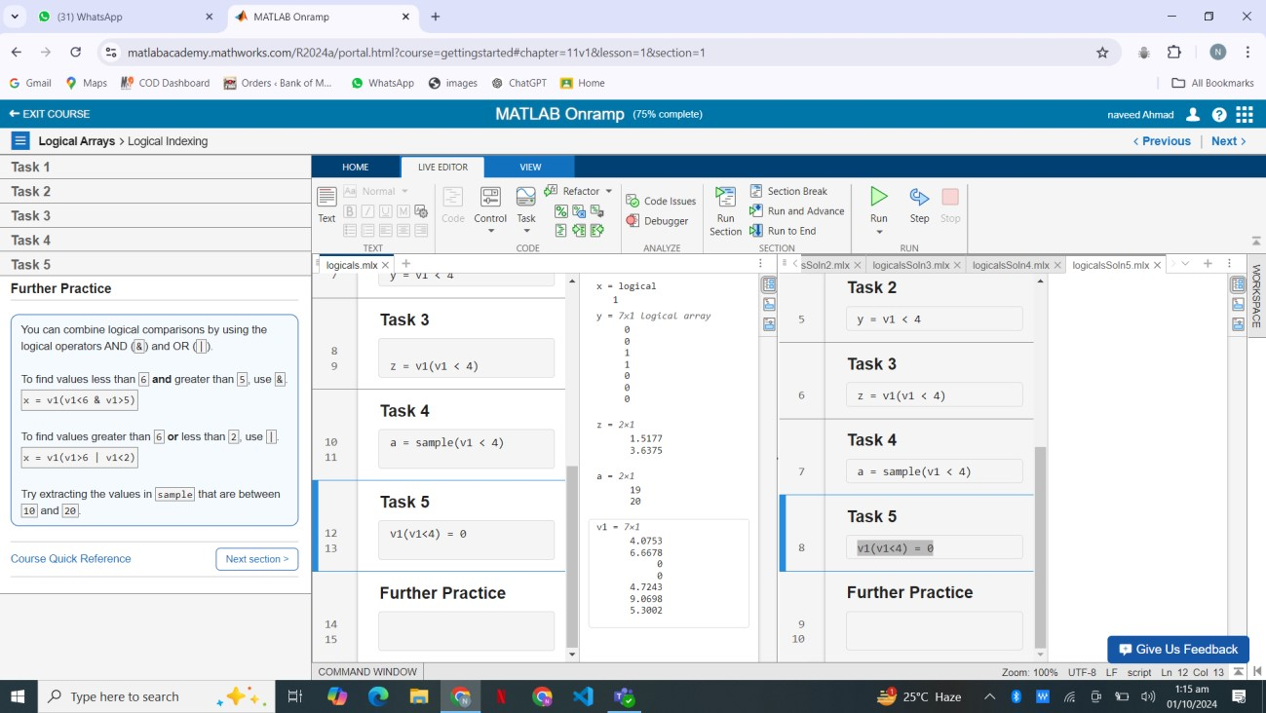

# For loop:

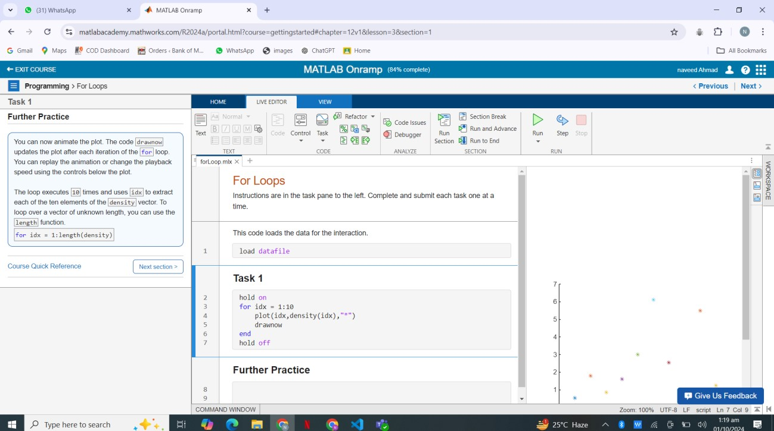

I learned to use loops in MATLAB for efficient repetition of tasks and streamlined code execution.

# Final project :

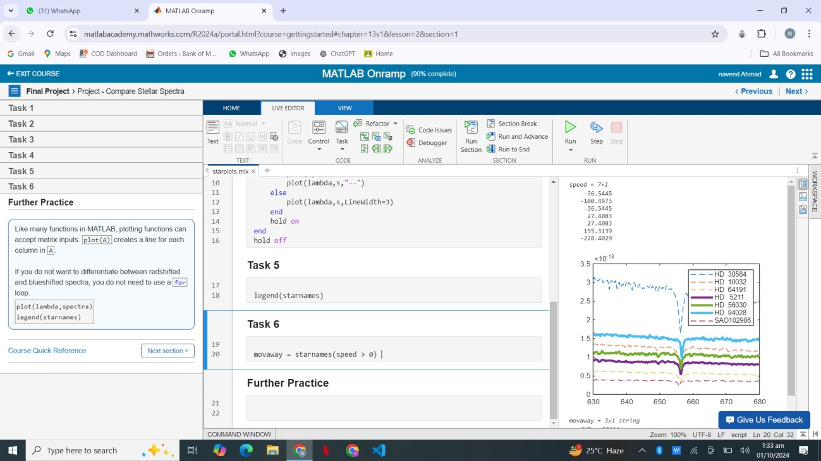

**Course completion:**

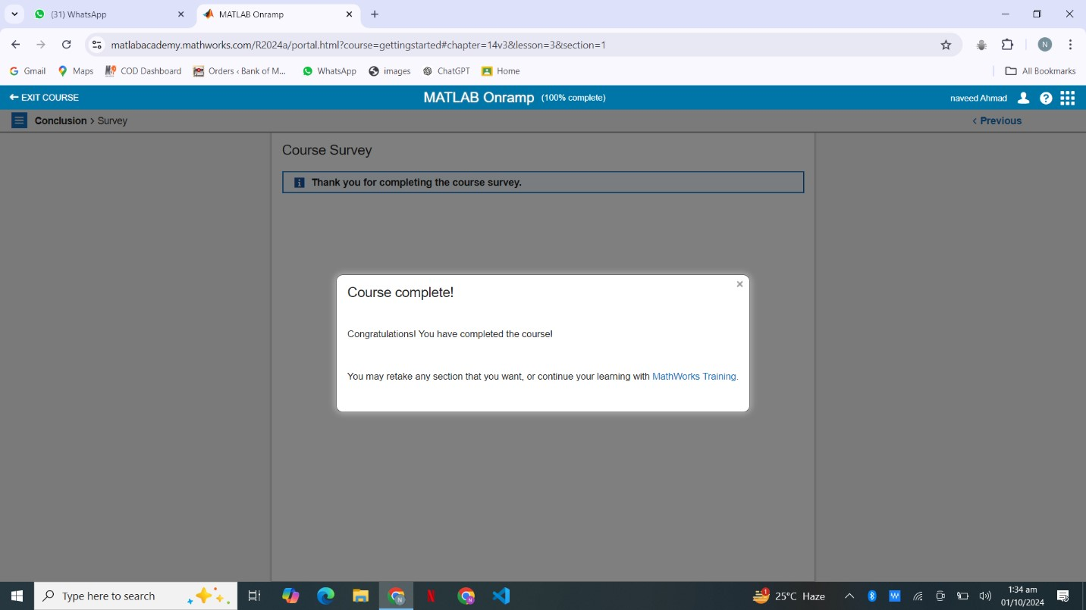

**Certificate:**

